

**CO-502 B DD Commercial Dishwasher**

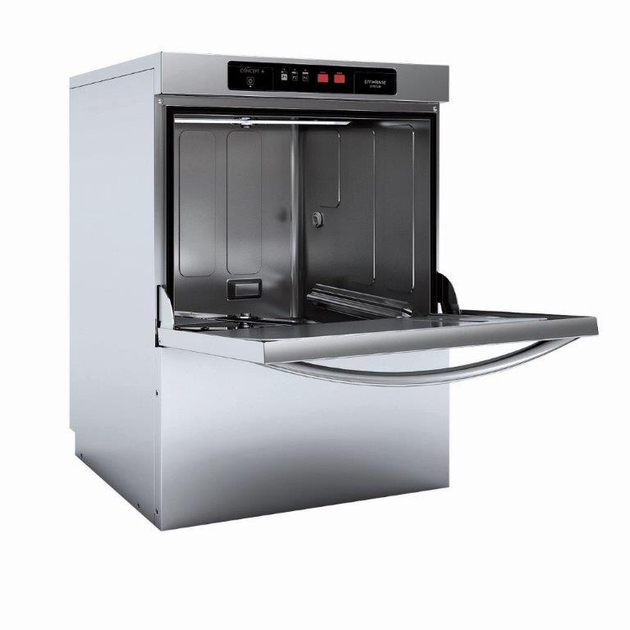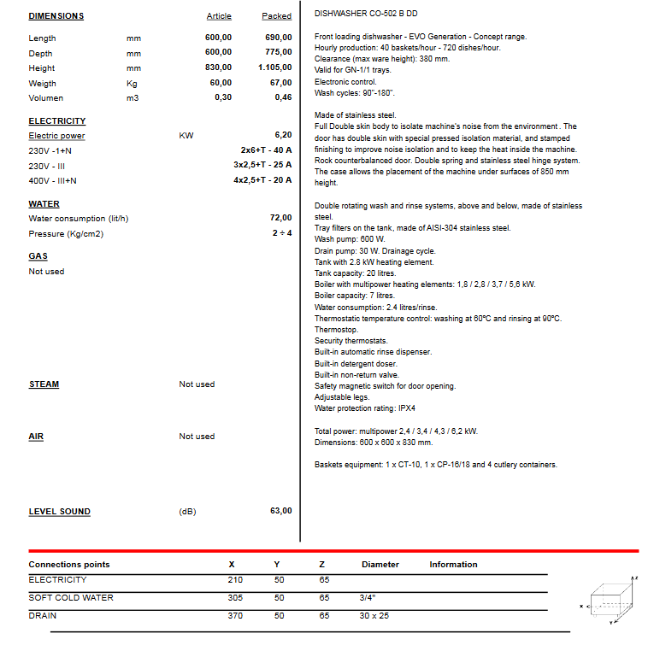

**FAGOR WS-CO-502BDD Commercial Dishwasher**